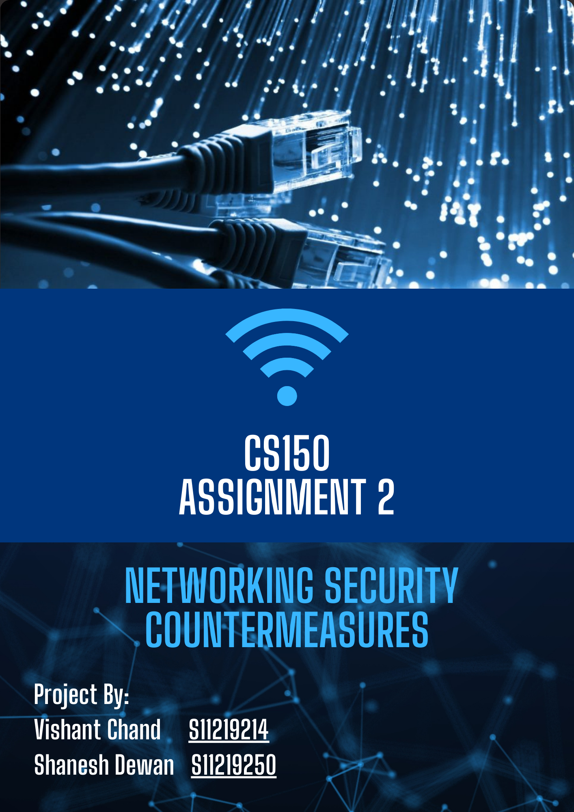

**Table of Contents**

Contents

**Introduction** 3

**Technicalities** 3

**Hardware Specifications** 4

**Warranty and Backup Service** 6

**Setup and Labor costs** 6

**Price Analysis with other Vendors** 7

**Software requirements** 8

**Security requirements** 9

**Access level** 9

**Threat Assessment** 10

**Recommendations** 10

**Conclusion** 11

# **Introduction**

This technical report will focus on providing a solution to the board for approval as there is major concern of security breach during the pandemic the school community is looking forward to implementing better monitoring for the safety of the school. As due to the pandemic, robberies can be an issue to the school premise. Taking into consideration the proposal specifications, the report will outline a detailed information on the technicalities, product specification, price comparisons, etc. The report will also cover the threat assessment section which includes the potential threats to the security of the implemented network, prioritizing threats based of the potential impacts, countermeasures to eliminate the threat and recommendations for the future. A packet tracer file will also be presented to show how the monitoring system will be configured and show the specific devices used and cables to ensure working connectivity.

# **Technicalities**

Currently, the school does not have any surveillance system. Due to the pandemic, there is a need for an implementation of a proper surveillance system. This will prevent any trespassing or damage to the school assets as there will be 24/7 monitoring. Some of the main components for the implementation are:

* 4 x 6mp cameras for monitoring and also must have motion detection.
* 1 PC for display and storage. However, an NVR (Network Video Recorder) can also be utilized for storage.
* A monitor
* Support for remote surveillance.
* Provision to add 4 more cameras in future.

Below is a surveillance system design which is how the new monitoring system will be implemented:

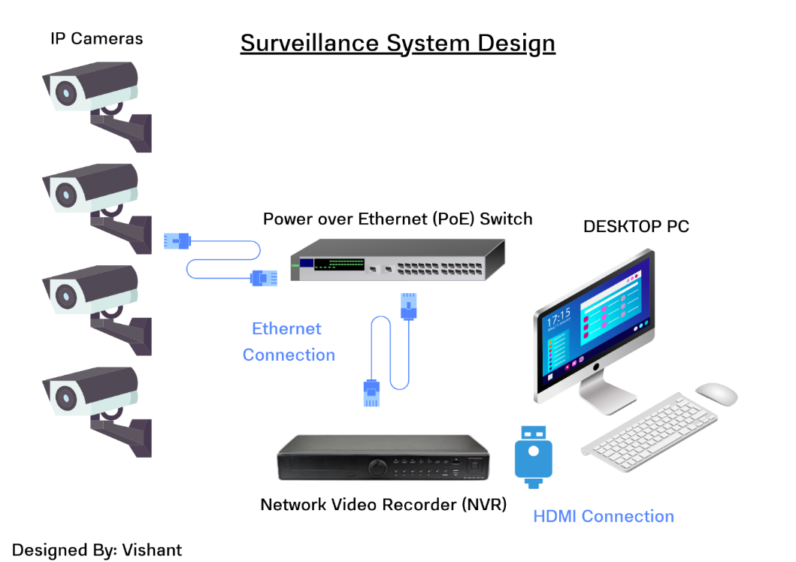

As shown in the design above, the cameras will be connected to a PoE switch (is a switch that transmits data and power through an ethernet cable). Along with the NVR, and monitor.

While looking into various specifications and brands of devices that will be needed, it is important to consider the requirements of the board. These requirements include:

* Brand of devices (Some brands may not perform as efficiently in comparison to other brands).
* Specifications (Different devices may have certain advantages over others). Such as for the security cameras their recording resolutions, operating temperature levels and weather conditions resistance. Similarly, the channel in an NVR is important as this indicates the ports available for the IP cameras. It will also counter the provision of adding more cameras in the future.
* Backup and support (A return policy should be available by the vendors to the consumers incase there is any problems with the deices)
* Price (It is important to take note that expensive doesn’t always mean it is better because some consumers do not want better, they want the product to satisfy their requirements only).

**Hardware Specifications** (all hardware was found on [www.bondwell.com.fj](http://www.bondwell.com.fj))

|  |  |  |  |  |
| --- | --- | --- | --- | --- |
| Component | Quantity | Description | Model | Price (FJD) |
| IP Cameras | 4 | -High quality imaging with 6 MP resolution  -Excellent low-light performance.  -Supports motion detection.  -Water and dust resistant (IP67)  - Height adjustable | Hikvision DS-2CD2T66G2-4I | $580.00 |
| PC | 1 | -Intel core i3-9100  -16GB Ram  -256GB NVME Storage  -Win10 Pro 64bit  -Supports Ethernet, USB, and HDMI connection. | HP PC PRODESK 600 SFF | $1687.00 |
| NVR | 1 | - Protocol: TCP/IP, DHCP, DNS, NTP, UPnP  -16-channel IP video input  -Supports up to 8 MP resolution  -Capacity: up to 10TB  -Network interface: RJ-45  - USB Interface: 2 USB 2.0 | TP LINK VIGI NVR 16 CHANNEL  (VIGI NVR1016H) | $385.00 |
| PoE Switch | 1 | -16 Port PoE+  - 16 10/100/1000Mbps RJ45 ports  - Supported ports to transfer data and power over a single cable  - Simple network set-up on top of plug-and-play connectivity  - Web-based user interface and management utility simplify configuration | TP LINK SWITCH 16-PORT GIGABIT PoE+  (TL-SG1016PE) | $525.00 |
| Ethernet Cable | 20M x 5 | -Produced by an ISO9001 and ISO14001 certified manufacturer  -100% tested, performance verified by 3P, UL Listed  -250MHz Slimline Snag less Molding  -Covered by lifetime warranty  -Range: -20~60C  -RJ45 (Male) connectors  -20m cable length | CABLE PATCH DYNAMIX CAT6 UTP 20MTR BLUE SNAGLESS | $58.00 |
| HDMI Cable | 3M x 1 | -Supports 1920 x 1080 @ 60Hz  -24k Gold plated connector  -Support Ethernet | VCOM HDMI 19 MALE TO MALE 2.0V BLACK RED 3M | $26.00 |
| Monitor | 1 | - Optimum Resolution: 1920x 1080 @ 75Hz HDMI 1920x1080 @ 60Hz VGA  - Signal Input: VGA 1, HDMI 1.4 1  - Power Supply: 19V DC, 1.31A  - Power Consumption (typical): 18W  - Adjustable Stand: Tilt: -5 ~ 20 | MONITOR AOC 21.5" 1920 x 1080 HDMI+VGA VESA TILT | $320.00 |
|  | | | Total Cost | $3813.00 |

# **Warranty and Backup Service**

The products mentioned above are locally available in Fiji which can be bought from Bondwell. The prices were available at their online webpage: [www.bondwell.com.fj](http://www.bondwell.com.fj) . Bondwell is one of Fiji's largest IT Retailer and Solutions Provider with over 27 years of expertise.

The following are the warranty duration for the products:

* IP cameras- 36 Months
* NVR- 24 Months
* PoE switch- 5 Years
* PC- 12 Months
* Cables- N/A (Enquire while purchasing)

The backup services available at Bondwell are:

* Hardware installation and maintenance- Installation can be done by trained professionals if needed and also necessary maintenance can be done by the vendor at a certain period of time.
* Technical support available to customers while purchasing products such as IP cameras.

# **Setup and Labor costs**

If the IP cameras and equipment’s are purchased from local vendors such as Bondwell, then the setup and installation can be done free of charge provided it will be a simple setup. Buying from an international vendor requires hiring professional technicians to setup the camera or installing yourself to save cost. However, there are some factors which can have an impact on the cost of installation such as:

* Number of cameras to be installed.
* Types of cameras to be installed.
* Wired or wireless.
* Locations of cameras including floors.
* Setting up and configuring the IP cameras.

# **Price Analysis with other Vendors**

|  |  |  |  |  |
| --- | --- | --- | --- | --- |
| Product | Local Vendor Price | International Vendor Price (FJD) | Shipping Cost  (FJD) | References to International vendor |
| Camera | $580.00x4 | $449.04x4 | - | https://www.securitywholesalers.com.au/product/hikvision-ds-2cd2t66g2-4i-acusense-6mp-exir-outdoor-bullet-cctv-camera-up-to-80m-ir/ |
| PC | $1687.00x1 | $80.97x1 | - | https://www.amazon.com/HP-ProDesk-600-G1-SFF/dp/B07BCGW85X |
| NVR | $385.00x1 | $228.71x1 | - | https://www.amazon.in/TP-Link-NVR1016H-Continuous-Recording-Monitoring/dp/B094VL1V76?th=1 |
| PoE Switch | $525.00x1 | $143.00x1 | - | https://www.amazon.com/TP-Link-Unmanaged-Rackmount-Lifetime-TL-SG1016PE/dp/B0721V1TGV?th=1 |
| Monitor | $320.00x1 | $194.00x1 | $29.49 | https://www.amazon.com/E2270SWDN-21-5-INCH-1920-1080/dp/B016UPDUBO |
| Ethernet Cable | $58.00x5 | $9.99x5 | $31.80 | https://www.amazon.com/Cable-Matters-Snagless-Ethernet-Black/dp/B089DL9FCD/ref=sr_1_3?adgrpid=79847062925&hvadid=673522952761&hvdev=c&hvlocphy=1005780&hvnetw=g&hvqmt=b&hvrand=11514248128681322756&hvtargid=kwd-20017756&hydadcr=2774_13713710&keywords=cat%2B6%2Bethernet%2Bcable&qid=1698283582&s=electronics&sr=1-3&th=1 |
| HDMI cable | $26.00x1 | $6.99x1 | $29.49 | https://www.amazon.com/CableDirect-High-Grade-I-S-Shielding-Ethernet/dp/B008U7SL8I/ref=sr_1_2_sspa?crid=26O2ZK6LUDLYE&keywords=hdmi+cable&qid=1698283665&sprefix=hdmi+cab%2Caps%2C406&sr=8-2-spons&sp_csd=d2lkZ2V0TmFtZT1zcF9hdGY&psc=1 |
| Total+Shipping | $3813.00 | $2585.56 | |  |

The table above shows a price comparison between local vendors and international vendors. The total price of buying products from a local vendors is calculated to be $3813.00 FJD and products bought from the referenced international vendors is $2585.56. Therefore, it can be clearly seen that buying from international vendors can be significantly cheaper.

While it may be cheaper to buy from international vendors, there are other factors which should be considered first. Such as warranty, maintenance over time, return policy and shipping costs as this can be higher than the original price of the product. If items are bought internationally, local vendors will refuse to do maintenance as that was not bought from them, and if necessary, the customer will have to pay extra to professionals to do regular maintenance or the initial setup.

# **Software requirements**

Software’s are needed to operate essential hardware functions. The IP-camera requires software’s for proper function and user controllability.

IP camera

* 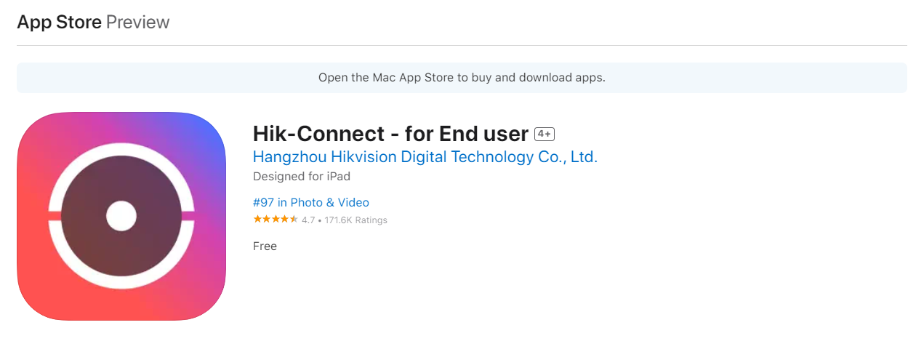Hikvision products have their own app which is available in Appstore for both IOS devices as well as Android called Hik-Connect.
* The software is also available for PC/MAC users as well as called HikCentral Professional which can be downloaded from there official website: <https://www.hikvision.com/au-en/support/download/software/>

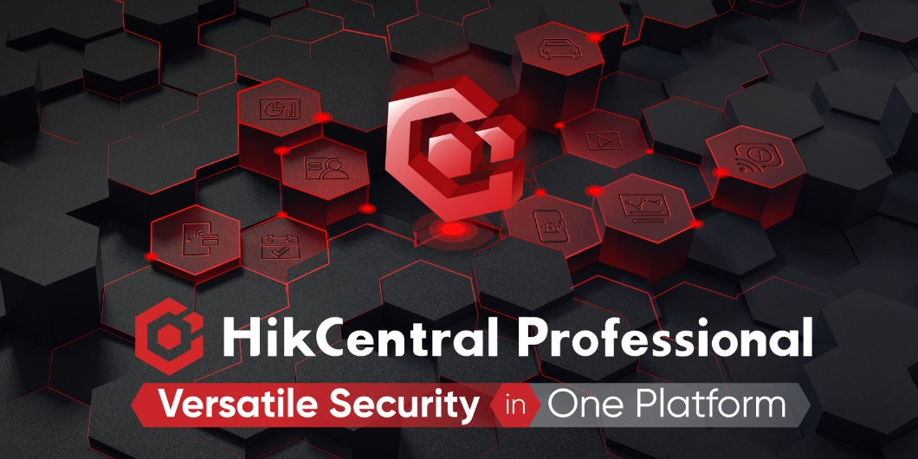

This software allows clients to:

* Real-time monitoring
* Video playback
* Motion detection alarm notification
* Share devices to others with limited permissions

# **Security requirements**

IP cameras are considered an IOT (Internet of Things) device, therefore anyone with internet connection can access it. This poses a high risk to the overall security surveillance system. However, this can be avoided by implementing the following:

* Changing the default username and password- Most IP cameras come with default username and password. Most clients do not change this which could be vulnerable to the surveillance system. It is recommended that upon the initial installation and setup of the IP cameras that clients change the default username and password.
* Keeping the firmware updated- Regular firmware updates and patches are released for the IP cameras. It is important to keep your surveillance system updated.
* Network segmentation: It is advised that IP cameras should be connected to a different network than the main network. This could prevent any security vulnerabilities as hackers can use the IP cameras as an entrance point to the main network. Having the IP cameras put on a different network will also not have any effect to the bandwidth of the main network because IP cameras consume lot of bandwidth, therefore it is recommended to put them on a different network.

# **Access level**

* Without user permissions and roles, any user with unauthorize access can view live recordings, change camera related settings and worse disable the entire surveillance system. User permissions and roles also help manage different levels of access and control for different users, such as administrators, operators, viewers, or guests.

Creating user permissions and roles for IP camera access depends on the IP camera model, software, and network configuration. Most IP cameras such as (Hikvision DS-2CD2T66G2-4I) have a web interface that allows you to create and manage user accounts and permissions, such as live view, playback, PTZ control, configuration, or remote access. You can also assign user roles like admin, operator, viewer, or guest with predefined permissions. Alternatively, using a video management software (VMS) or network video recorder (NVR) can also help you create and manage user accounts and permissions for IP camera access. These solutions may also offer features such as user groups, schedules, audit logs, or encryption. The following website was looked into for information-<https://www.linkedin.com/advice/1/how-do-you-manage-user-permissions-roles-ip-camera-access>.

# **Threat Assessment**

Potential security threats include:

* Outdated firmware version of IP cameras
* Default and Weak Credentials
* Physical damage to the cameras such as theft
* Threat within the organization (Staff misusing the surveillance system)
* Using a local storage-based system.

Threat prioritization & Countermeasures:

* Outdated firmware version of IP cameras- Regularly checking for updates and keeping the firmware updated.
* Default and Weak Credentials- Setting up custom username and a strong password using combinations such as (Capital letters, numbers, special characters).
* Physical damage to the cameras such as theft- Place the IP cameras at locations where it is not prone to theft or damage. Consider certain heights and spots.
* Threat within the organization (Staff misusing the surveillance system)- It is important to keep this in mind while assigning access and roles. As this is a crucial step towards the integrity and security of the surveillance system.
* Using a local storage-based system- The client storing and having access over the recordings is important. However, storing the recordings on a trusted cloud storage server can be a better option due to the additional security provided by them.

# **Recommendations**

Additional recommendations to enhance the security of the network include:

* Pen-testing- This involves hiring an expert to try to exploit the system. Having the surveillance system put to test can be beneficial. This can help in identifying vulnerabilities in the system and implementing fixes to strengthen the surveillance system.
* Installing and setting up a firewall.
* Training staffs how to use the new surveillance system to prevent any unwanted changes by them which could be a security risk.
* Purchase IP cameras which are reliable, provides regular updates and patches, user support, important functionalities and has an application or app support for users to interact.

# **Conclusion**

In conclusion, surveillance system are crucial to maximize security for any organization. There are various factors to consider while planning and implementing a surveillance system. While the report showcases that buying from an international vendor can be cheaper, there are other factors such as warranty, policy return, maintenance, cost of setup, vendor reliability. Therefore, buying from a local vendor would be a better option as they cover all the factors mentioned earlier. This report includes all information for the products required for the surveillance system, security requirements and threat assessment. A packet tracer file was also created to show a basic setup of the surveillance system and configuration.